
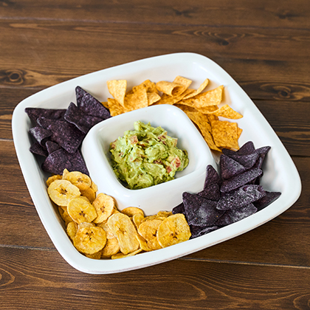

Hugs & Dishes!
Thank you for registering for Juliska! With a completed registry of $1,200 or more in Juliska items, receive a complimentary Puro Chip and Dip.

Please fill out the information below and email along with a copy of your registry, with all Juliska selections noted, totaling $1,200 to hello@juliska.com:
Name:

Address:

City/State/Zip:

Phone Number:

Email address:

Wedding Date and Registry #:

Please contact hello@juliska.com with any questions.

Terms and conditions: Only valid on registries with fulfillment of $1,200 or more of Juliska product. Proof of registry fulfillment must be included along with redemption form for Juliska Puro Chip and Dip available while supplies last. Limit 1 per registry. Void where prohibited, taxed, or restricted by law. Juliska is not responsible for lost, misplaced, or stolen vouchers. Cannot be exchanged or redeemed for cash. Amount of purchases subject to approval. This certificate may not be reproduced, traded, or sold. Please allow up to 30 days for processing.

